Project Design Phase-II
Data Flow Diagram & User Stories

Date | 14 July 2026
Team ID
Project Name | UCab Premium - MERN Cab Booking System
Maximum Marks | 4 Marks

Data Flow Diagrams:
A Data Flow Diagram (DFD) is a traditional visual representation of the information flows within a system. A neat and clear DFD can depict the right amount of the system requirement graphically. It shows how data enters and leaves the system, what changes the information, and where data is stored.
Example: DFD Level 0 (Industry Standard)
Example: (Simplified)
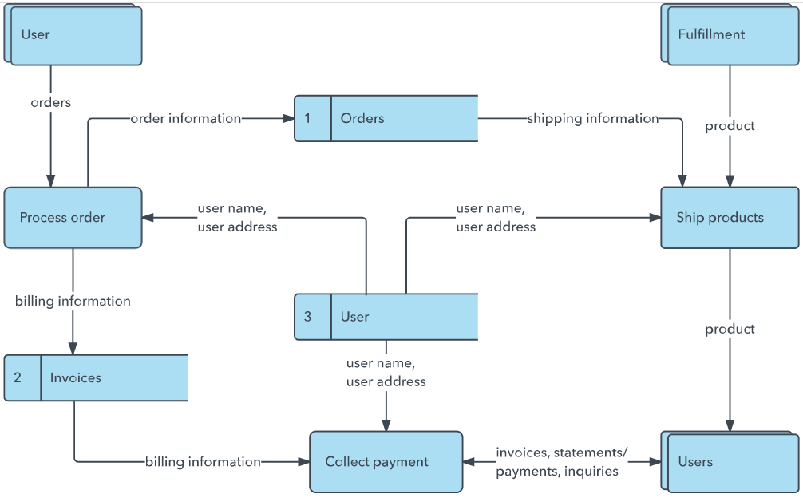


Our Data Flow Diagram (Level 1) – UCab Premium
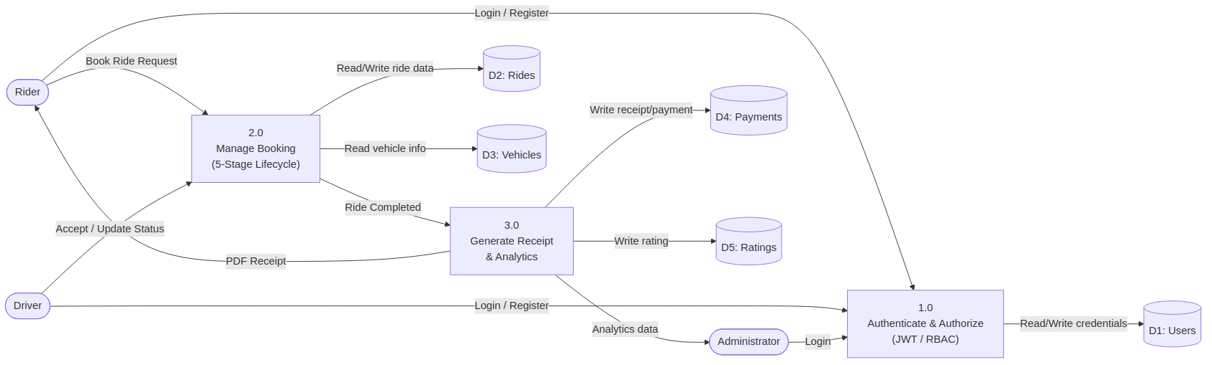
Figure: Rider, Driver, and Admin interactions flow through Authentication, Booking Lifecycle, and Receipt/Analytics processes into the MongoDB data stores.
User Stories
Use the below template to list all the user stories for the product.
User Type | Functional Requirement (Epic) | User Story Number | User Story / Task | Acceptance criteria | Priority | Release
Customer (Mobile user) | Registration | USN-1 | As a user, I can register for the application by entering my email, password, and confirming my password. | I can access my account / dashboard | High | Sprint-1
 |  | USN-2 | As a user, I will receive confirmation email once I have registered for the application | I can receive confirmation email & click confirm | High | Sprint-1
 |  | USN-3 | As a user, I can register for the application through Facebook | I can register & access the dashboard with Facebook Login | Low | Sprint-2
 |  | USN-4 | As a user, I can register for the application through Gmail | I can register & access the dashboard with Gmail Login | Medium | Sprint-1
 | Login | USN-5 | As a user, I can log into the application by entering email & password | I can log in and access my role-based dashboard | High | Sprint-1
 | Dashboard | USN-6 | As a Rider or Driver, I can view a dashboard with active/past rides and an earnings/trip summary | I can see my ride history and earnings/spending totals | Medium | Sprint-2
Customer (Web user) | Booking a Ride | USN-7 | As a Rider, I can search nearby available cabs and book a ride in real time | I can view nearby drivers and confirm a booking | High | Sprint-2
Driver | Ride Management | USN-8 | As a Driver, I can accept or reject incoming ride requests and update my availability status | I can see incoming requests and toggle my online/offline status | High | Sprint-2
Administrator | Admin Dashboard | USN-9 | As an Admin, I can monitor all riders, drivers, and rides and view platform-wide analytics | I can view live ride status and Recharts-based analytics on the admin dashboard | High | Sprint-3
Rider | Payments & Receipts | USN-10 | As a Rider, I can view a fare estimate and download a PDF receipt after trip completion | I can download a PDF receipt from my ride history | Medium | Sprint-3
Rider | Ratings & Feedback | USN-11 | As a Rider, I can rate my driver and leave feedback after a completed trip | I can submit a star rating and comment once the ride is marked Completed | Low | Sprint-3

